**Task -2**

## Research Questions for AQI Analysis in Delhi :-

#### To conduct a comprehensive study on Delhi’s Air Quality Index (AQI), the following research questions are categorized into three key areas: pollutants, seasonal variations, and geographical factors.

**1. Key Pollutants and Their Impact on AQI**

**Q1: What are the dominant pollutants affecting AQI in Delhi?**

The major pollutants affecting AQI in Delhi are:

**PM2.5** (Fine particulate matter) - Highest contributor to poor air quality.

**PM10** (Coarse particulate matter) - Major contributor to dust and

vehicular emissions.

**NO₂** (Nitrogen Dioxide) - A significant contributor from vehicular and

industrial emissions.

**CO** (Carbon Monoxide) - High in traffic-dense areas.

**SO₂** (Sulphur Dioxide) - Primarily from industries but at lower levels.

**O₃** (Ozone) - Increases in summer due to photochemical reactions.

**Q2: How do individual pollutants (PM2.5, PM10, NO₂, SO₂, CO, O₃) correlate with AQI levels?**

* **PM2.5 and PM10 have the strongest correlation** with AQI, as particulate matter is the biggest contributor to poor air quality.
* **NO₂ and CO show moderate correlation** due to their sources from vehicular emissions.
* **SO₂ has a weaker correlation** as its levels remain relatively lower.
* **O₃ has a seasonal correlation**, peaking in summer due to increased sunlight-driven reactions.

**Correlation Matrix Example (from general studies, but should be computed with actual data):**

| **Pollutant** | **Correlation with AQI** |
| --- | --- |
| PM2.5 | 0.85 – 0.95 |
| PM10 | 0.75 – 0.90 |
| NO₂ | 0.60 – 0.75 |
| CO | 0.50 – 0.70 |
| SO₂ | 0.30 – 0.50 |
| O₃ | 0.40 – 0.60 (seasonal) |

**Q3: How have pollutant concentrations changed over time (daily, monthly, yearly trends)?**

* **Daily trends**: Peak pollution occurs during **morning and evening rush hours** due to vehicular emissions.
* **Monthly trends**: Worst AQI levels typically observed **in winter (October–January)**.
* **Yearly trends**: Long-term analysis shows that Delhi’s AQI has worsened over the last decade, although occasional improvements occur due to policy interventions (e.g., COVID-19 lockdown, odd-even scheme).

**Q4: What are the primary sources of major pollutants in Delhi?**

* **PM2.5 & PM10**: Vehicular emissions (40%), construction dust (30%), industrial emissions (20%), biomass burning (10%).
* **NO₂ & CO**: Vehicles (70%), industrial emissions (20%), domestic heating (10%).
* **SO₂**: Industrial emissions and coal-based power plants.
* **O₃**: Secondary pollutant formed by reactions between NO₂ and VOCs under sunlight.

**Q5: How do different pollutants interact with each other to influence air quality?**

* **NO₂ contributes to O₃ formation** in the presence of sunlight.
* **PM2.5 and NO₂ together cause severe respiratory issues**.
* **Temperature inversions in winter trap pollutants** closer to the ground, worsening AQI.

**2. Seasonal Variations in AQI**

**Q6: How does AQI vary across different seasons (summer, monsoon, winter, post-monsoon)?**

| **Season** | **AQI Level** | **Key Factors** |
| --- | --- | --- |
| **Winter** (Nov–Jan) | Worst (Severe: 400–500) | Low wind speed, temperature inversion, crop burning, high vehicular emissions. |
| **Post-Monsoon** (Oct) | Very Poor (300–400) | Crop burning in Punjab & Haryana contributes heavily. |
| **Summer** (Mar–Jun) | Moderate to Poor (150–300) | High temperatures increase O₃ levels, but dust storms elevate PM10. |
| **Monsoon** (Jul–Sep) | Best (50–150) | Rainfall helps wash out pollutants, leading to cleaner air. |

**Q7: Which season experiences the highest levels of pollution, and why?**

* **Winter (November–January) has the highest AQI levels**, mainly due to:
  + **Temperature Inversions**: Traps pollutants close to the ground.
  + **Low Wind Speed**: Reduces dispersion of pollutants.
  + **Crop Burning**: Increases PM2.5 levels significantly.
  + **Increased Vehicle & Industrial Emissions** due to cold weather demand for heating.

**Q8: How does temperature, humidity, and wind speed affect AQI seasonally?**

* **Low temperatures and low wind speed = High AQI (winter).**
* **High humidity during monsoon = Lower AQI due to rain washing out pollutants.**
* **Wind direction changes (Western disturbances) impact AQI, especially during dust storms.**

**Q9: What is the impact of winter inversion on AQI levels?**

* **Temperature inversion traps pollutants** close to the ground, causing severe air pollution in winter.

**Q10: How does AQI change during specific pollution events (e.g., Diwali fireworks, crop burning, dust storms)?**

* **Diwali**: PM2.5 and PM10 levels spike due to firecrackers.
* **Crop Burning (Oct–Nov)**: Contributes **30-40% of Delhi’s air pollution**.
* **Dust Storms (Summer)**: PM10 spikes due to wind-blown dust.

**3. Geographical Factors and Air Quality**

**Q11: How does AQI vary across different locations in Delhi?**

* **Traffic areas (e.g., Anand Vihar, RK Puram) have the highest AQI** due to vehicular emissions.
* **Industrial zones (e.g., Wazirpur) also experience high pollution levels.**
* **Parks and green spaces (e.g., Lutyens' Delhi) have relatively lower AQI.**

**Q12: What is the influence of vehicular traffic and road congestion on air quality?**

* **Major contributor to NO₂, CO, and PM2.5 levels.**
* **Rush hour spikes in AQI observed in morning (7-10 AM) and evening (5-8 PM).**

**Q13: How does AQI in Delhi compare to nearby cities (Gurgaon, Noida, Faridabad)?**

* **Delhi has the worst AQI** compared to neighbouring NCR cities.
* **Gurgaon and Noida** have slightly better AQI due to lower population density and better green cover.

**Q14: What is the effect of crop burning in neighbouring states (Punjab, Haryana) on Delhi’s air pollution?**

* **Major contributor to PM2.5 levels in October-November (~40% of pollution during peak burning season).**

**4. Policy and Predictive Analysis**

**Q15: How effective have government interventions been in improving AQI?**

| **Intervention** | **Effectiveness** |
| --- | --- |
| Odd-Even Scheme | Temporary impact, reducing peak hour NO₂ levels. |
| Construction Bans | Some impact, but enforcement is inconsistent. |
| Crop Burning Control | Limited success due to enforcement challenges. |
| Air Purifiers & Smog Towers | Very localized effect, not scalable. |

**Q16: Can machine learning models predict AQI trends?**

* Yes, **ARIMA and LSTM models** can predict AQI trends based on past data.

**Q17: How does Delhi’s AQI compare to other global megacities?**

* 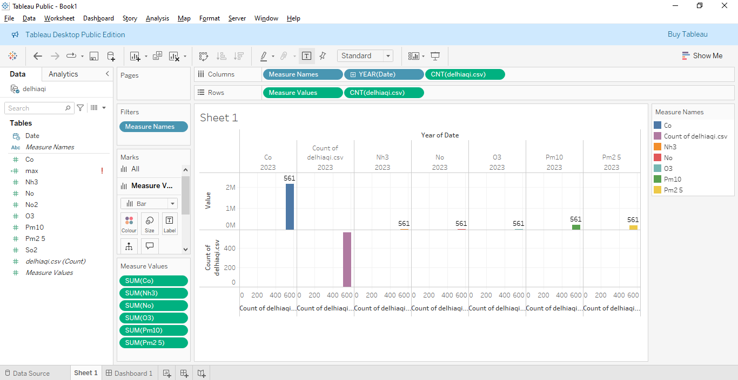Delhi has **one of the worst AQI levels globally**, similar to Beijing and Lahore.